


Group Assessment:
Individual Contribution of Each Group Member
Jack McCay | For the Kempower project, I was primarily responsible for conducting the external analysis to assess the company’s opportunities and challenges in expanding into the Italian market. This involved applying multiple strategic frameworks, including the Industry Life Cycle, PESTEL, Porter’s Five Forces, SWOT, and CAGE analyses. Through these tools, I examined key macro-environmental factors such as government incentives for EV infrastructure, economic barriers related to installation costs, and social and technological trends driving electric mobility adoption. I also assessed the competitive landscape and regulatory conditions shaping Italy’s high-power charging sector. Furthermore, I attended all meetings and edited the final report.
Patricia Kasense | I comprehensively examined, researched and composed the analysis of Kempower’s Value Chain, Competitor Analysis and the 7Ps Mc Kinsey Framework. This has allowed me to identify key competitors within the EV Charging Infrastructure in Italy that was a key element in understanding the key players in the industry and potential strategic alliances in the future. I visually prepared the diagrams to better understand Kempower’s strategic position and the overall understanding of the Italian market. Additionally, I actively participated in all group discussions, meetings and ensured that I stuck to all internal deadlines. I took the initiative that the poster was printed on time to guarantee readiness for the poster presentation ahead of Thursday.
Abhinav Uppal | I contributed significantly to this project by conceptualising Kempower’s expansion into Italy and conducting a detailed internal company analysis. Through the VRIO framework, I identified Dynamic Power Management (DPM) and the Megawatt Charging System (MCS) as the company’s main competitive strengths. I independently designed and created the poster presentation, ensuring visual and analytical coherence. Additionally, I played a leading role in shaping the report’s structure and flow, collaborating closely with my teammates to enhance the depth, clarity, and overall presentation quality of the project.
Himanshu Somani | I thoroughly researched, analysed, and wrote the section on Kempower Oyj – Company Overview & Structure. My work included compiling detailed information about the company’s background, governance model, business operations, and global strategy. I explored Kempower’s initiatives in Italy and the Nordic region, emphasizing its partnerships, technological innovations like DPM and MCS, and financial growth plans. I ensured the report presented a clear understanding of Kempower’s market expansion, operational approach, and strategic goals. The entire content was independently created and structured by me through comprehensive research, organization, and presentation of verified company data.
Rajni Garg | In this project, I analysed Kempower Oyj’s financial performance and market trends to support their operations in Italy. I reviewed revenue, EBIT, and cash flow data to identify patterns, risks, and opportunities. I also researched Tesla’s financing and EV infrastructure strategies, including the use of 0% financing to encourage adoption, and applied these insights to Kempower Oyj’s context. I developed revenue and EBIT projections, considering partnerships with Enel X and Free To X. I actively participated in all project meetings and assisted in preparing the report, including creating the table of contents to ensure clarity and structure.

Table of Contents
Executive Summary 4
Section 1 - Company Introduction 4
Section 2 - External Environment Analysis 5
Industry Life Cycle Analysis 6
PESTEL ANALYSIS 9
Porter’s 5 Forcers 10
CAGE FRAMEWORK 11
Section 3 - Financial Analysis 12
Financial Performance Overview (2021 → H1 2025) 12
Key Insights of Current Financial Data 13
Section 4 - Internal Analysis 13
Strategic Imperative – Italian Market Entry Via DPM and MCS 13
Value Chain 14
VRIO Analysis 15
McKinsey 7 PS Framework 16
Competitor Analysis 17
Section 6 - Recommendation 19
1. Strategic Rationale 19
2. Expanded Italian Strategy 20
3. Financial Strategy 20
4. Recommended Partners 20
5. Implementation Timeline and Risk Mitigation 21
Conclusion 22
Bibliography 22

Executive Summary
This report evaluates Kempower’s decision to prioritise internalisation within the Italian market due to a recent increase in demand and legislative push. This study will map out a strategic path forward for Kempower to become a key player in the fiercely competitive direct current (DC) fast charging infrastructure market.
Key findings
- Kempower’s strategic use of its Finnish manufacturing hub to supply modular DC charging units across Europe positions the company to efficiently scale operations in Italy while maintaining strong gross margins and production control.

- After reviewing Kempower’s financial statements, there is a clear strategic need for further market diversification, which showcases a high risk of dependence on European markets that are facing inventory corrections.

- Revenue growth from Italian expansion is projected at 10%-15% due to increased adoption of high-power chargers.

- From a cultural perspective, Italy’s relationship-oriented business environment makes a partnership-led market entry model the most effective approach for Kempower.

- Kempower introduced their brand in Bologna, Italy, by partnering with transportation operator TPER and showcasing their products during an exhibition.

- Kempower has already initiated strategic partnerships by suppling its technology to Enel X to design Italy’s first megawatt charging station in Verona. These types of partnerships will continue helping with the brand establishment in Italy and allow them to focus on other locations within the Italian market

Section 1 - Company Introduction
Kempower is a Finnish company that designs and manufactures DC fast-charging solutions for electric vehicles (EVs) (Kempower, 2025a). Kempower was established in 2018 and has rapidly grown into a global player (Kempower, 2025a). Their “vision is to create the world’s most desired EV fast charging solutions for everyone, everywhere” (Kempower, 2025a). Kempower is publicly listed on the Nasdaq Helsinki (Kempower Oyj, 2025). In recent years, Kempower has expanded its geographic footprint (Kempower, 2025a). While maintaining its core production and R&D base in Lahti, Finland, the company has also established production capacity abroad, including in the US through their partnership with PowerUp America (Kempower, 2025b). Overall, there are 66 countries that operate Kempower chargers (Kempower, 2025a). Recently, Kempower became the market leader for DC fast charging solutions in Norway, which is the country with the highest EV adoption rate (Kempower, 2025g; Murray, 2025). In June, Kempower announced Bhasker Kaushal as their new CEO and he has more than 20 years’ experience with international firms where he has driven growth and revenue (Kempower, 2025c).
Kempower develops both hardware and software components across the EV charging value chain (Kempower, 2025a). The business model centres on modular, scalable fast-charging hardware and a complementary cloud-based software platform which allows charge point operators, fleets, and utilities to manage the charging infrastructure (Kempower, 2025d). Kempower positions itself as a full-stack provider of EV charging infrastructure: serving public charging networks, commercial fleet depots, off-highway electrification, and OEM industrial and mobility segments (Kempower, 2025d). The modular and scalable nature of its systems allows operators to begin with lower power setups and expand as demand grows (Kempower, 2025d).
Current Italian Initiatives
For this project we want to be informed on what Kempower has currently done so far in Italy. They are already active in the Italian market, targeting public-transport operators and bus-depots as a key strategic segment. In Bologna, Kempower’s technology was used to electrify one of Europe’s largest bus depots operated by TPER (Kempower, 2024). The facility can accommodate up to 500 vehicles and features up to 25 fast-charging points (Kempower, 2024). In the Emilia-Romagna region, Kempower partnered with TSG Italia and operator SETA S.p.A to deliver more than 50 ultra-fast charging points across depots in Reggio Emilia and Piacenza (Kempower, 2025e). These projects showcase Kempower’s execution capability in the Italian market.
Expanded Italian Strategy
Kempower’s strategic goal is to establish a strong position in Italy’s growing EV charging market as part of its broader European expansion plan. The company has already laid the foundation for this by leveraging its manufacturing hub in Lahti, which serves as its main production and export base for European operations. Building on the initial Italian projects, Kempower’s expanded Italian strategy focuses on deploying high-performance DC fast charging solutions modified to the country’s evolving mobility needs. Kempower’s primary market targets in Italy include public transport depots, logistics and delivery fleets, and highway corridor infrastructure. By expanding its partnership with local utilities and installation providers, Kempower aims to scale its presence and position itself as a preferred technology partner for Italian e-mobility projects. This expansion into Italy represents a crucial step in Kempower’s broader European growth strategy.

Section 2 - External Environment Analysis
The purpose of this section of the report is to analyse the external environment and existing macroeconomic factors influencing Kempower’s continued expansion into Italy. Kempower has experienced rapid growth across Europe with a CAGR of 343.5% (Financial Times, 2025) and is now evaluating further market opportunities to expand its presence across Southern Europe (Kempower, 2022). In this section we will specifically focus on assessing Italy’s macroeconomic, political, and institutional context to determine whether the external environment is suitable to a successful market entry. Comparative frameworks may be applied to generate structured insights into Italy’s external environment relative to Finland, Kempower’s home market.

Industry Life Cycle Analysis
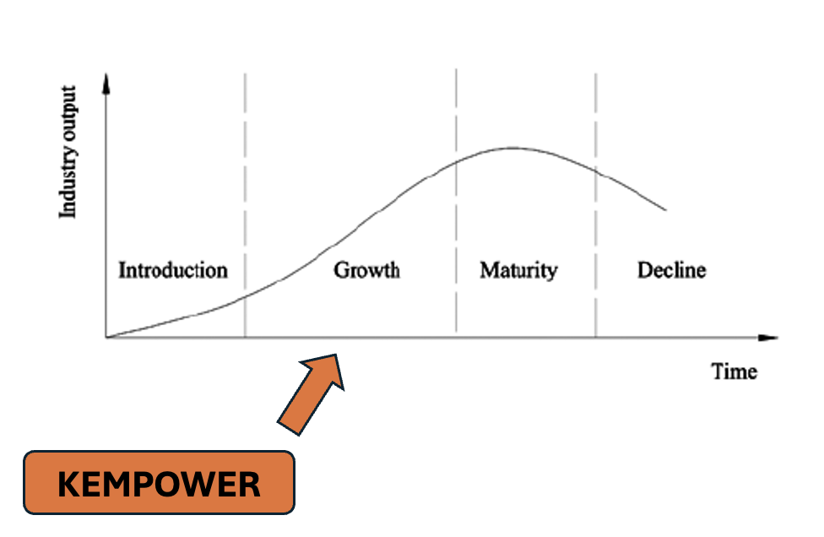
The Italian electric charging sector is firmly positioned in the growth stage of the industry life cycle, characterised by rapid expansion, strong policy backing, and increasing market adoption. Driven by EU regulations, Italy is witnessing accelerating infrastructure deployment supported by substantial public funding and private participation. However, coverage gaps, high public debt, and bureaucratic red-tape remain a challenge for market entrants (De La Feld, 2025; Ursino, 2025).

Rapid Market Expansion
The Italian HOC charging hardware sector is in the growth stage, showcased through increased deployment and supportive policies. The public charging network expanded over 30% in 2023 to over 26,000 points, and grew to around 58,000 by the end of 2024 (Morzenti and Ruccione, 2024; Magic, 2025). High-power DC chargers are a minority, with only 14% of Italian public chargers being DC fast chargers, compared to the 20% EU average (Morzenti and Ruccione, 2024). EV adoption is also increasing steadily, however, this is starting from a low base. Battery EVs only accounted for 5% of new car sales in 2024, far below EU average (Autovista24, 2025a).
EU Level Framework
At EU level, Italy’s charging rollout is guided by the Alternative Fuels Infrastructure Regulation (AFIR) and Trans-European Transport Network (TEN-T). These set binding targets to create a dense, reliable charging network along major European routes. By end-2025, fast chargers for cars and vans must be installed every 60km along TEN-T corridors (Kempower Oyj, 2024). Additionally, by 2030 there are set to be further increases in coverage and power (Kempower Oyj, 2024). These requirements cover major Italian motorways like Rhine-Alpine. Under AFIR, public charging operators must ensure open and transparent access by offering ad-hoc payment options and sharing real-time operational data through national access points (European Commission, 2023). Funding is available through Connecting Europe Facility (CEF) and AFIF initiatives. A €1 billion AFIF packaged launched in 2024, and offers grants to deploy charging solutions along TEN-T routes and cities (European Climate, Infrastructure and Environment Executive Agency, 2024).
Italy’s National Initiatives
Italy’s primary program to expand EV charging is funded through the National Recovery and Resilience Plan (PNRR). The plan allocated €741 million to install nearly 21,000 chargers by 2025 (Magic, 2025). Also, the initiative offers a grant of up to €11,000 for those earning less than €30,000 and €9,000 grant for those earning up to €40,000 (Alternative Fuels Observatory EC Europa, 2025). Furthermore, it aims to support micro enterprises by paying for up to 30% of the new vehicles purchasing price (Alternative Fuels Observatory EC Europa, 2025). The Ministry of Environment (MASE) launched tenders in 2022, but participation was low due to strict measures (Brambilla, 2025). The rules have since been relaxed and by late 2024, only €96 million of the €640 million available had been awarded (Brambilla, 2025). Due to the low uptake, the government has signalled it may reallocate the funds elsewhere (Brambilla, 2025). Beyond the PNNR, the Ministry of Enterprises offers an 80% subsidy for business, professionals, and condominium associations to install charges (Confcommercio, 2025). This subsidy is primarily targets semi-public or private charging, at workplaces, retail parking etc., with the objective of expanding the charging network beyond motorways (Confcommercio, 2025). Furthermore, some cities run concession tenders allowing private companies to install chargers on public or semi-public land. For example, Reggio Emilia launched a 10 year concession in late 2024 for companies to build and operate citywide chargers (Comune di Reggio Emilia, 2021).
Energy Market Context
Italy’s power prices are amongst Europe’s highest. Italy’s current wholesale electricity price is €109.95/MWh which is a considerable reduction from 2023, when it was the highest in EU at €128/MWh (Market Observatory for Energy, 2024). This translated into steep retail prices for Italian households, with citizens living in Rome paying €415/MWh with taxes in 2023, which was one of the highest figures in Europe. (Market Observatory for Energy, 2024)
The Italian government are investing significantly to upgrade grids for renewables and electrification. Italy’s TSO Terna announced a €23 billion, 10-year plan to help support the country’s energy transition (Amrellini, 2025). Other notable projects include the Tyrrhenian Link and the Adriatic Link, which aims to increase inter-regional transfer capacity, and resolve local congestion and improve the stability and security of the grid (Amrellini, 2025). However, grid connections delays remain a major bottleneck in Italy, the grid faced ‘virtual saturation’ with 350GW of renewable projects waiting for connection, more than five times the 2030 target (Lardizabal, 2025). To manage this, Italy is implementing new “micro-zonal” planning and is prioritising projects that already have permits (Lardizabal, 2025). Moreover, long distribution service operators (DSO) procedures can slow EV charger deployment.
Permitting Timelines
A significant obstacle to charging infrastructure in Italy is the long permitting and approval process. Installing a new public charging station entails navigating various bureaucratic steps, and on average it takes around 250 working days from initial request to the point where a charger is functioning (Abu Eideh, 2021). Furthermore, approval delays can stretch from 6-18 months (Anariev Consulting, 2025).
Infrastructure Deployment Progress
Italy’s charging infrastructure while expanding quickly has not yet achieved full coverage, reinforcing that the sector is in growth stage and not maturity. By late 2024 the country still had under 10 charging points per 100 km of road, below other large EU countries (Morzenti and Ruccione, 2024). Furthermore only 35% of motorways had fast chargers every 60km (Anariev Consulting, 2025). However, this is improving as new stations come online. For example, the Autostrade network’s HPC sites at 50km intervals already exceed EU targets (Mobilize & Autostrade per l’Italia, 2025). The government’s goal of 110,000+ public charging points by 2030 further underscores the on-going build up (Shijiazhuang Maxwell Technology Co. Ltd., 2025).

PESTEL Analysis
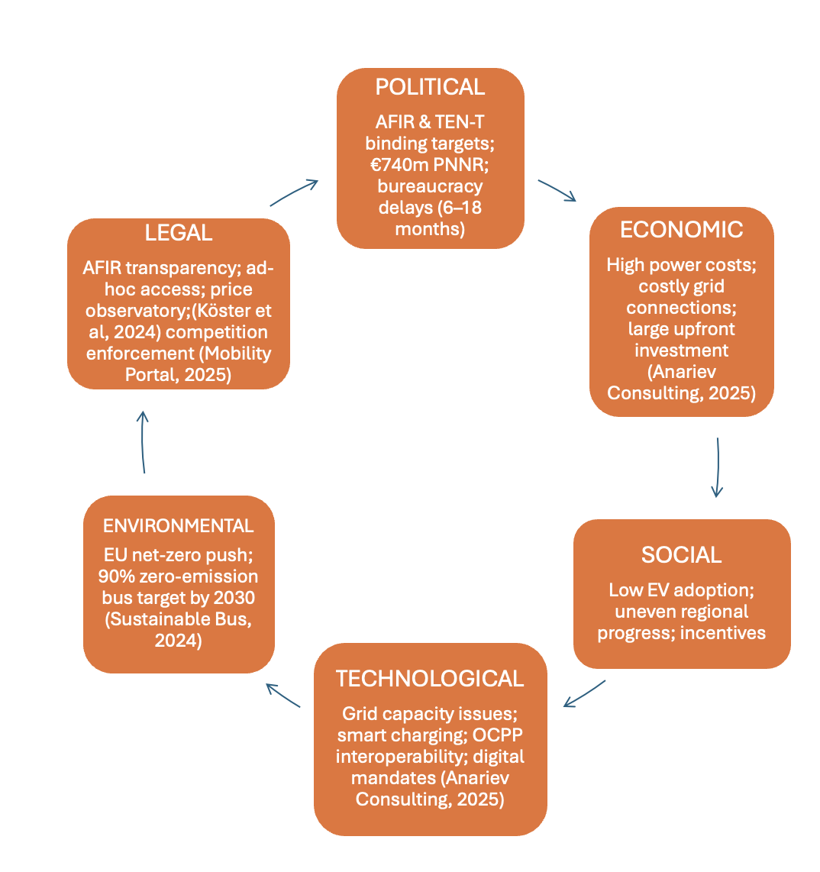

Porter’s 5 Forcers
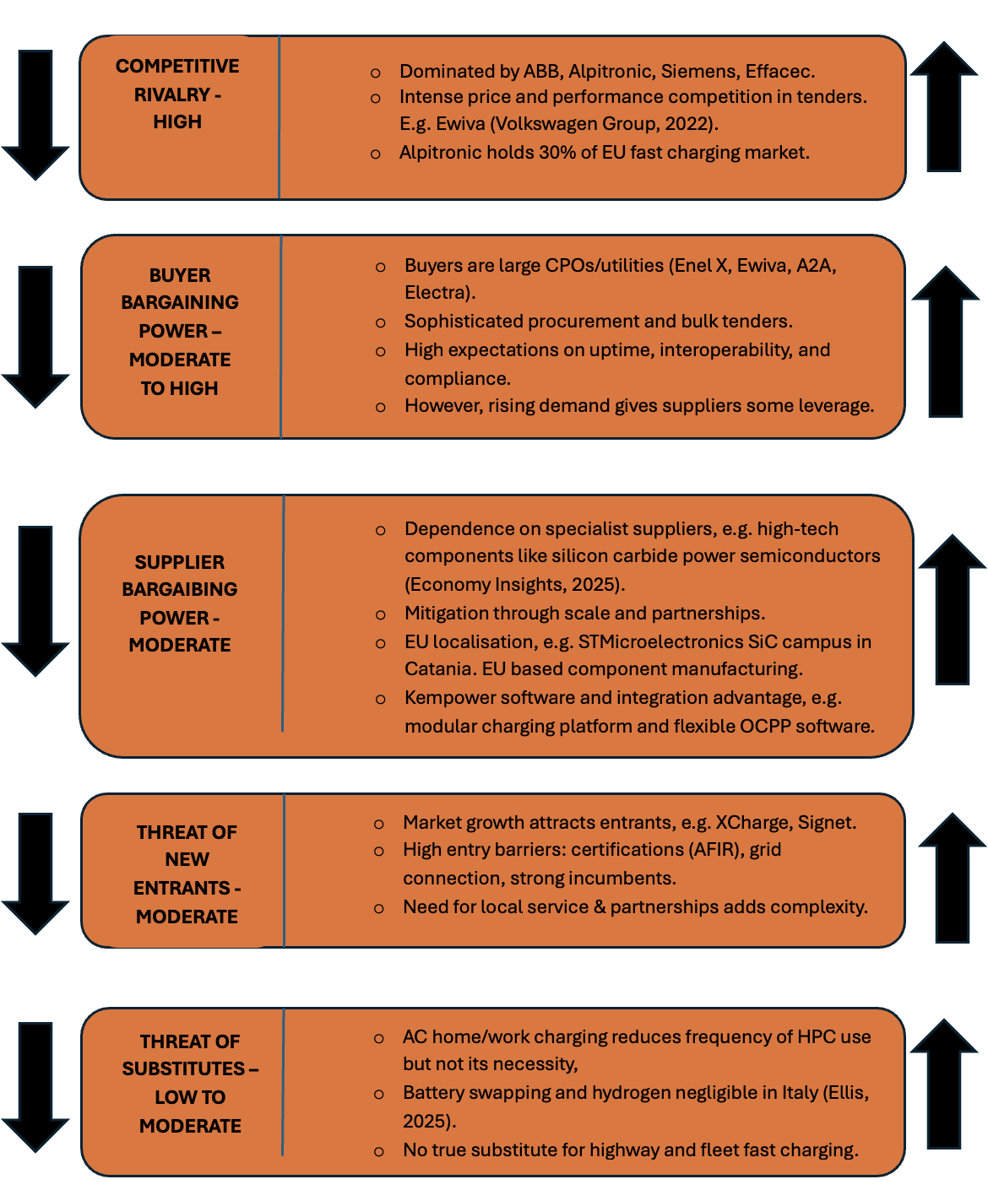

CAGE FRAMEWORK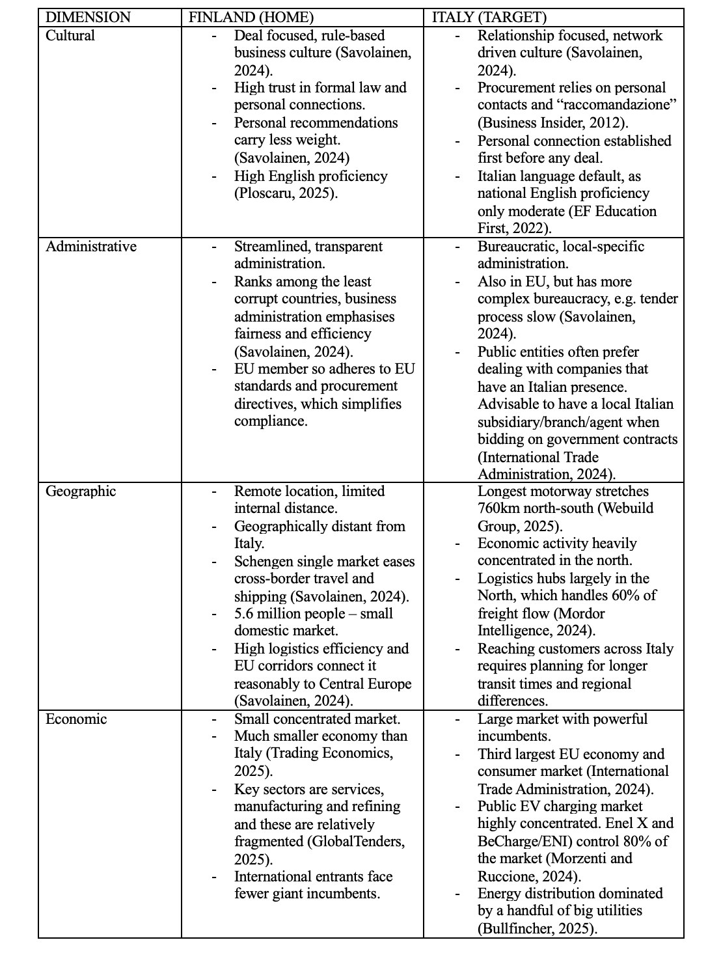

Section 3 - Financial Analysis

Financial Performance Overview (2021 → H1 2025)
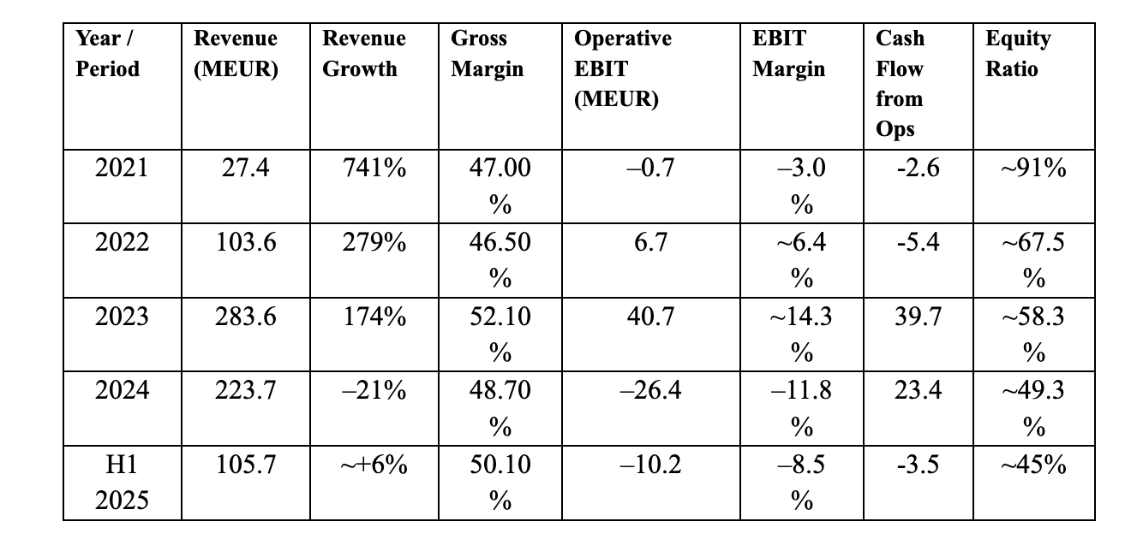

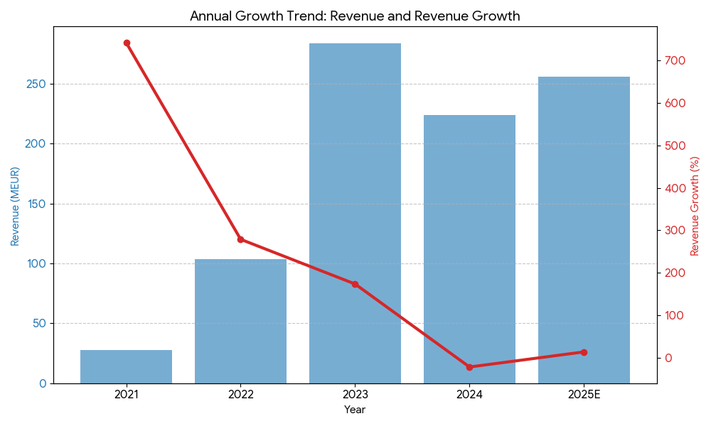

Key Insights of Current Financial Data
Kempower grew rapidly from €27.4 m in 2021 to €283.6 m in 2023, driven by strong product-market fit. Revenue fell 21% in 2024 due to European market slowdowns and customer inventory corrections. Profitability has been uneven—EBIT peaked at 14.3% in 2023 but dropped to –11.8% in 2024; while gross margins stayed healthy, around 47–52%. Cash flow has mostly been negative, though H1 2025 shows early signs of recovery, with revenue at €105.7 m and EBIT margin improving to –8.5%. The equity ratio declined from ~91% in 2021 to ~45% in H1 2025, reflecting increased investments. Overall, Kempower’s financials show resilience and growth potential, reinforcing the opportunity to expand in markets like Italy.

Section 4 - Internal Analysis

Strategic Imperative – Italian Market Entry Via DPM and MCS
After reviewing Kempower’s financial statements, we have identified a clear strategic need for market diversification. In 2024, Kempower experienced a 21% revenue decline and an 11.8% Operating EBIT Margin, as reported in the Kempower Annual Report (2024), which highlighted a high risk of dependence on European markets currently facing inventory corrections. However, the rebound in order intake during the first half of 2025 suggests that the market correction is easing (Kempower Corporation Interim Report, 1 January–30 September 2025), positioning the company for growth.
Italy presents a promising and untapped market with two main infrastructure challenges:
a.) widespread grid capacity issues for public charging, and
b.) an urgent need to electrify heavy-duty logistics routes (TEN-T).
Therefore, this proposal recommends Kempower to pursue a technology-driven entry strategy, focusing on its core strengths: Dynamic Power Management (DPM) and Megawatt Charging Systems (MCS).

Value Chain
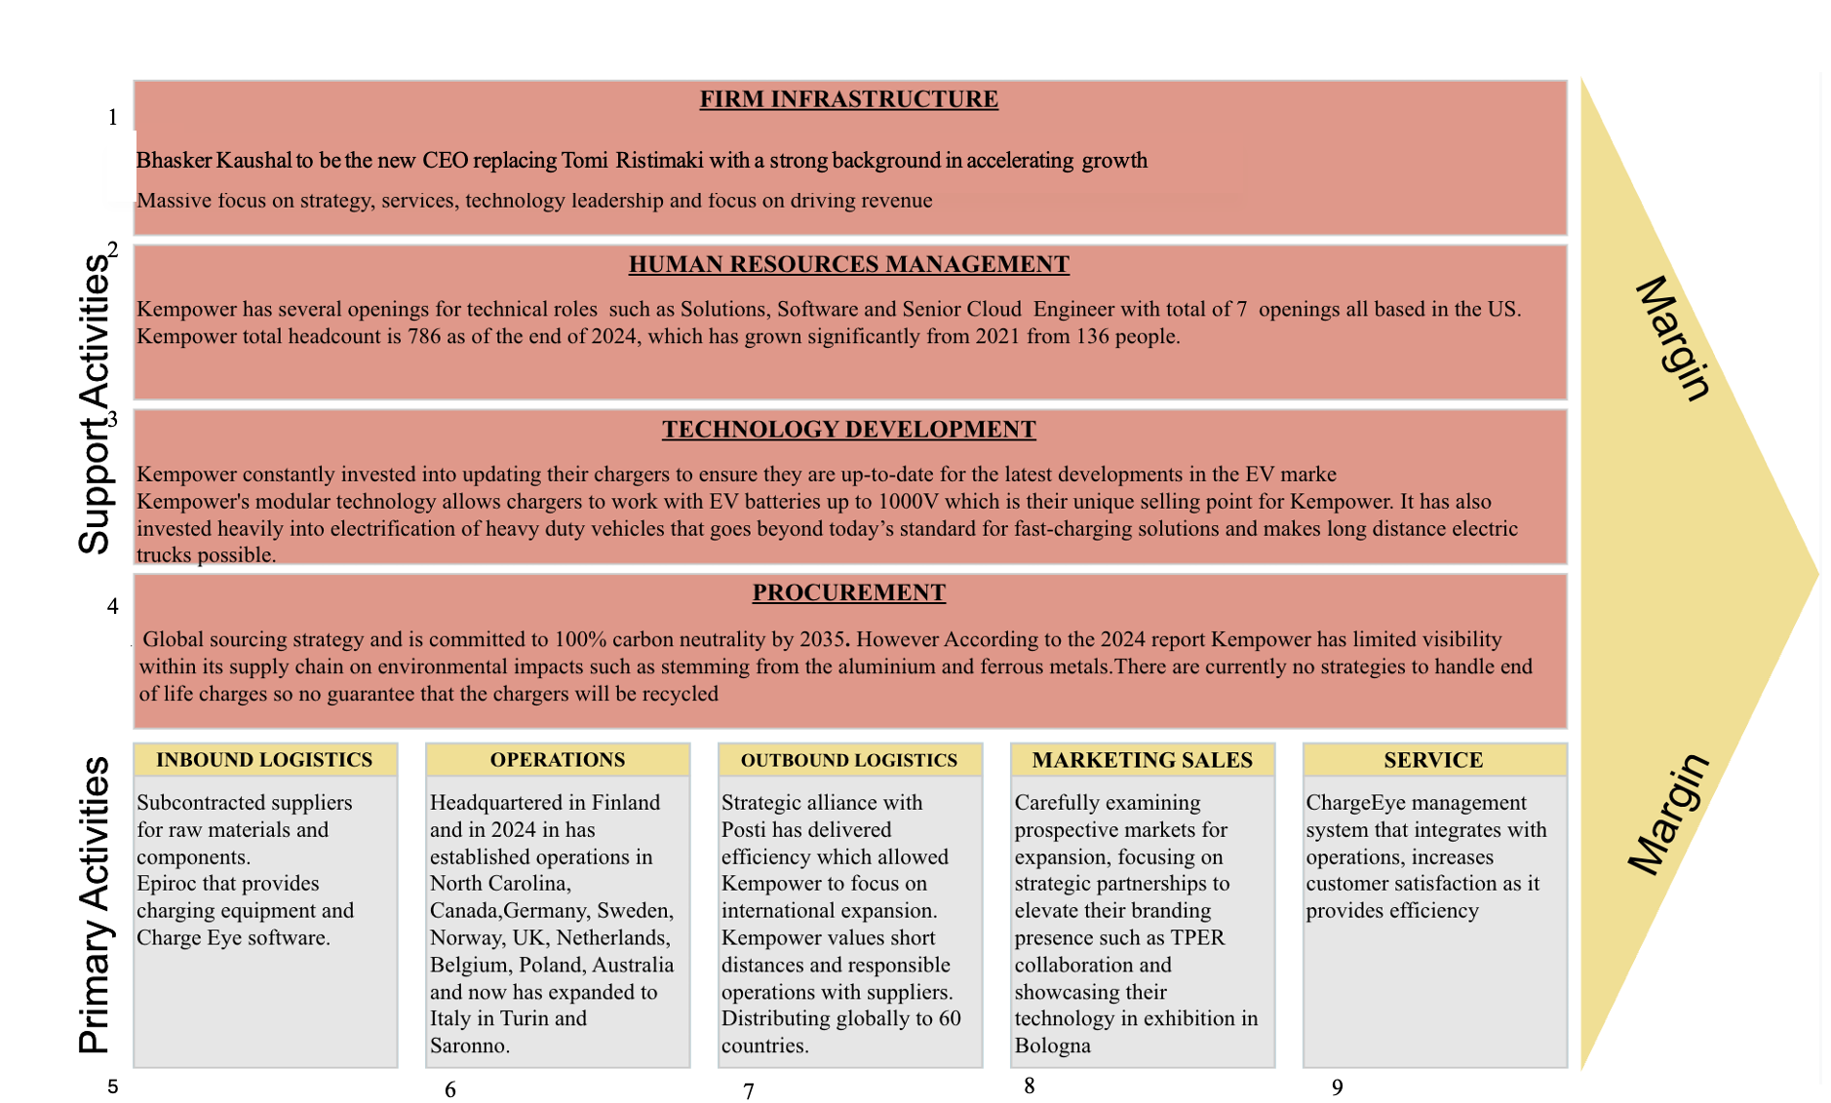

Sources:
¹ (Electrive Infractructure , n.d.)
² (Kempower - Investments, n.d.)
³ (European Commission, 2025)
⁴ (Case of Conduct )
⁵ (Cicero Shades of Green, 2022), (Kempower, 2021)
⁶ (Kempower About Us, n.d.), (Kempower, n.d.)
⁷ (Vuola, 2025), (Posti, 2025)
⁸ (Kempower, 2022)
⁹ (Kempower , n.d.)

VRIO Analysis
Capability 1: Dynamic Power Management (DPM) & ChargEye Software
VRIO Criterion | Evaluation & Sourced Justification
Value (V) | Yes. It directly solves high CAPEX and grid constraint problems for partners. DPM "optimizes the distribution and allocation of electrical power to balance supply and demand reducing grid congestion" (Kempower, n.d.-b). This makes the charging site "grid-friendly" and "cost-effective" for the operator (Kempower, n.d.-a).
Rarity (R) | Yes. True, granular DC dynamic sharing is rare. A July 2025 ABI Research report ranked Kempower as a "Market Leader" in commercial EV charging, citing its "market-leading dynamic load management solution" as a primary strength over competitors (PR Newswire, 2025).
Imitability (I) | Costly to Imitate. This capability is rooted in historical conditions and causal ambiguity. It is a direct result of decades of R&D in industrial DC power supplies from its parent company, Kemppi, which was a "pioneer in arc welding" and "the first welding company to use inverter technology in the 70s" (Kemptron, n.d.). This deep engineering expertise is not easily replicated.
Organization (O) | Yes. Kempower is fully organized to exploit DPM. The entire hardware ecosystem (Power Unit + Satellites) and software (ChargEye for CPOs and retail) is designed to monetize this feature by giving CPOs granular control, monitoring, and billing capabilities for their public charging hubs (Kempower, n.d.-c).

Capability 2: Megawatt Charging System (MCS) Technology
VRIO Criterion | Evaluation & Sourced Justification
Value (V) | Yes. MCS is the only technology that can enable the electrification of long-haul heavy-duty trucks. This market is a key EU priority (AFIR) and critical for Italy's logistics corridors. A 2025 ICCT report states the EU will need up to 5,300 public megawatt chargers by 2030, a market which is essential for "long-haul trips" (Basma & Schmidt, 2025).
Rarity (R) | Yes. As of 2025, MCS is a first-mover technology. The same July 2025 ABI Research report that named Kempower a "Market Leader" also cited its "impressive high-power DC chargers, including MCS solutions" as a key reason for its top-tier ranking, alongside giants like Siemens and ABB (PR Newswire, 2025).
Imitability (I) | Costly to Imitate. The R&D barrier to safely manage power is immense. Kempower's unique advantage is that its MCS is an upgradable system. Customers can "upgrade existing systems to MCS by combining two 600 kW Kempower Power Units." This modular path-dependency is incredibly costly for competitors to replicate (Kempower, n.d.-d).
Organization (O) | Yes. Kempower is strategically organized to capture this market. It has a dedicated 5-year, €10 million R&D initiative, the to "accelerate especially the development of high-power charging solutions for electric trucks" (Kempower HETE).  "Heavy Electric Traffic Ecosystem (HETE)" program,
This VRIO analysis confirms that DPM and MCS are Kempower's primary sources of sustained competitive advantage, making them the best technologies to lead the market entry.

McKinsey 7 PS Framework
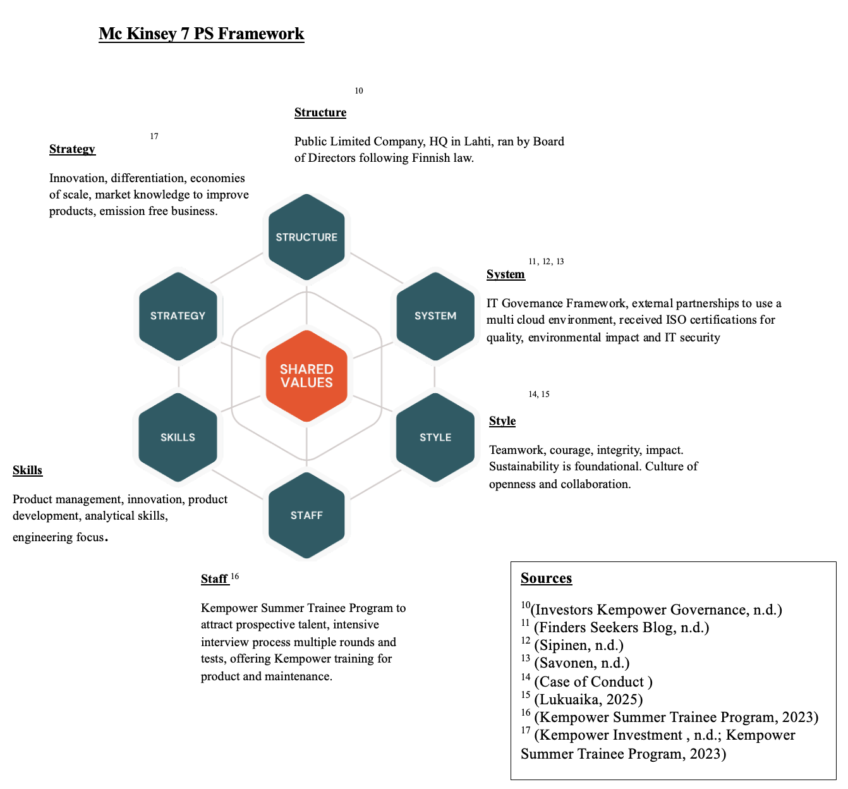

Competitor Analysis
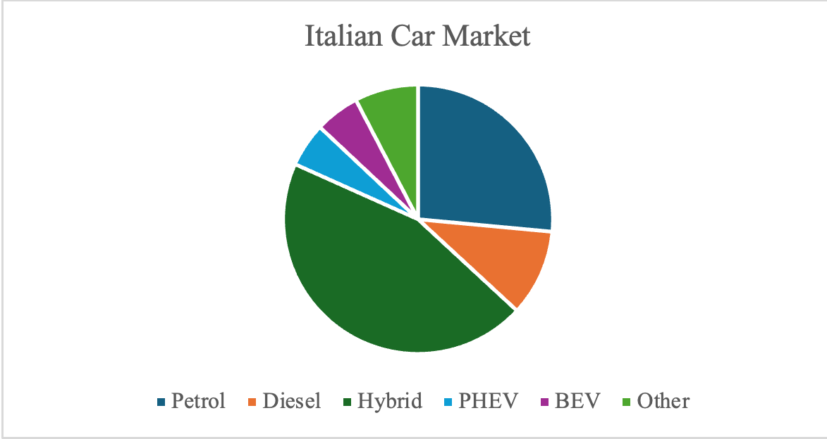
Source: (Autovista Group News, 2025b)

Company Name | Target Market | Competition | Characteristics | Products
Fimer | Public, ¹⁹residential and commercial target audiences. | Moderate | Customer centric, EV owners and businesses target market, 70 years of experience, 1100 employees, innovative. | AC/ DC fast chargers up to 150KW, residential charging units, charging accessories, commercial charging stations
Scame | Public, ²⁰residential, commercial audiences | Moderate | Fully Italian 23 years in business, expanded into manufacturing, advanced features, screen protection, intuitive chargers 640 employees, 3 production facilities. | AC/ DC 150KW, well mounted charging units, charging stations, connectors adapters and charging cables.
Be Charge | Public,21 residential, commercial audiences | Moderate | Cost effective, owned by Be Power, leveraging its manufacturing structure and quality management processes, received funding from EU to construct high speed electric charging networks in Europe | Public fast charging stations, charging accessories, residential charging stations, up to 150KW.
Hypercharger | Public, 22residential, commercial audience, heavy duty vehicles | High | Parent company Electronic, innovative EV charging solutions, EV specialist many years of experience, most technologically advanced charging stations, collaborating with EV manufacturers | DC fast chargers, charging accessories up to 1000KW.
Gigieffe | ²³Public, residential, commercial audience | Moderate | Main supplier for various industries – service sectors marinas, 4000 sq production facility, innovative EV charging stations | AC/DC chargers, fast charging stations, column chargers up to 150KW, charging accessories.

Sources:
¹⁸(Squintani, 2019)
¹⁹(Alpitronic, n.d.)
²⁰(Gigieffe Products, n.d.)
²¹(FIMER Products and Services , n.d.)
²²(SCAME, n.d.)
²³(EV Chargin Business Guides, n.d.)

Section 6 - Recommendation
After conducting our analysis we recommend that Kempower pursue the opportunity to expand their Italian operation. However, before we outline our expansion strategy it is useful to understand the drawbacks of such a strategic move.
Firstly, there are some internal constraints. Kempower’s rapid scaling has strained cash flow, and the company remains loss-making at EBIT level. Entering a new market with complex regulatory procedures and significant capital requirements could exacerbate financial pressures. Furthermore, Kempower’s new CEO Bhasker Kausal, presents potential uncertainty in decision-making and operational alignment during expansion.
Externally, the Italian market introduces some contextual risks. Bureaucratic permitting delays, regional administrative fragmentation, and uneven grid readiness can hinder deployment speed. Cultural and business norms favour relationship-based transactions, meaning that success depends on cultivating meaningful local partnerships rather than purely transactional sales.
However, if managed carefully through careful investment, local collaboration, financial discipline, the Italian expansion represents a sustainable pathway for Kempower’s European growth.

Strategic Rationale
The external environment analysis reveals that Italy is a viable and strategically attractive market for Kempower’s continued European expansion. The country’s high power DC charging sector is in a strong growth phase, and is being supported through government policy which is encouraging EV adoption and improving infrastructure.
Geographically, the northern regions of Italy, like Lombardy, Veneto, and Emilia Romagna, should be the areas Kempower focuses on initially. These regions have the highest concentration of EV adoption, established charging infrastructure, additional municipal incentives, and are heavily industrialised. Focusing efforts here would enable Kempower to align with existing grid readiness with a strong local customer base, ensuring substantial utilisation. From this northern hub, subsequent expansion into central and southern regions can follow as EV uptake and grid readiness improve.
Culturally, Italy’s relationship-oriented business environment makes a partnership-led market entry model the most effective approach. Italian business decisions are often influenced by trust, personal relationships, and previous collaboration. Therefore, establishing long-term collaborations with local charge point operators and utilities will provide instant credibility and help navigate Italy’s complex bureaucracy.

Expanded Italian Strategy
Kempower’s strategic goal is to improve its position in Italy’s EV charging market by leveraging its Finnish manufacturing hub as its export base. The company has already demonstrated success in Italy through the TPER Bologna bus depot project, one of Europe’s largest, developed in partnership with TSG Italia. This marked a major milestone in the efforts to electrify Italy’s public transport network and highlights Kempower’s ability to deliver large-scale charging solutions.
The expanded Italian strategy focuses on deploying Kempower’s DPM and MCS technologies across three priority segments:
  - Public transport depots, to support e-bus electrification.
  - Logistics fleets, to meet heavy-duty charging demands.
  - Highway corridors, to enable long-distance e-mobility aligned with EU’s AFIR regulation.
The initial focus should remain on Northern Italy, where there is suitable infrastructure and industrial activity to create a strong foundation for future regional expansion.

Financial Strategy
Kempower’s expansion in Italy should focus on scaling its DPM and MCS solutions across additional public charging hubs and key highway logistics corridors. Historical performance shows the company can achieve high gross margins (~50%) even during growth, and leveraging existing infrastructure keeps incremental costs low.
To support rapid rollout, Kempower could offer 0% financing or flexible payment plans to partners, reducing barriers to investment and ensuring faster uptake. This approach mirrors strategies used by companies like Tesla in the US and Europe, where partner financing helped expand charging networks quickly without straining corporate cash flow (Aguilar 2024).
Revenue growth from the Italian expansion is projected at 10–15%, driven by increasing adoption of high-power chargers and grid-optimized solutions. Operative EBIT is expected to improve as scale and utilization increase, while cash flow can turn positive within 12–18 months. Overall, this financially disciplined expansion balances growth, profitability, and risk, positioning Kempower for sustained success in Italy.

Recommended Partners
To execute this dual-pronged strategy, Kempower must target the specific Italian partners whose core business is solved by these two technologies.
Recommended Product System | Target Italian Partner | Strategic Rationale
Dynamic Power Management (DPM)  (For Public Charging Hubs) | Enel Group (Enel X Way) or Eni (Plenitude) | Grid & Scale: These are Italy's largest utilities, and their main problem is that scaling a national network is a costly nightmare. Kempower's DPM is the answer. It slashes their upfront grid connection costs and helps them run their charging hubs more profitably by smartly managing the power they have.
Megawatt Charging System (MCS)  (For Highway Logistics) | Autostrade per l'Italia (ASPI) / Free To X | Mandate & Future-Proofing: Free To X is the company ASPI created to handle one huge job: rolling out EV chargers across Italy's main highways, which is something the EU (through AFIR) requires. This makes them the most important partner for MCS, because that's the only tech that can actually handle the 2030 charging rules for electric trucks.
Kempower’s optimal strategy for Italy should be a technology-led entry. This can be achieved through DPM to form an immediate and high-value alliance with a major company like Enel X and to upsell MCS to secure future-proof contracts with highway operator Free To X.

Implementation Timeline and Risk Mitigation
Kempower should proceed with a phased, partnership-driven market entry into Italy. In the short term (0-6 months), the company should establish a presence in Northern Italy, strengthen alliances with Enel X Way, TSG Italia, and Free to X, and showcase its DPM and MSC technologies at exhibitions. The main risks at this stage are regulatory delays and cultural barriers. These can be mitigated by employing local legal advisors and Italian speaking managers familiar with local business norms.
Over the following (6-18 months), Kempower should launch pilot installations with public-transport operators such as TPER, and deploy MCS chargers along logistics corridors managed by APIS under the EU’s AFIR regulation. To increase adoption, Kempower could begin offering the 0% financing to partners while leveraging EU and PNNR funding to offset cash constraints.
In the longer term (18-36 months), the should open regional service centres and expand southwards as grid readiness improves. Competitive pressures from firms like ABB and Hypercharger can be countered through continued differentiation based on modular design, and high efficiency. If executed correctly, this phased pathway positions Kempower to establish a profitable presence in Italy within three years.

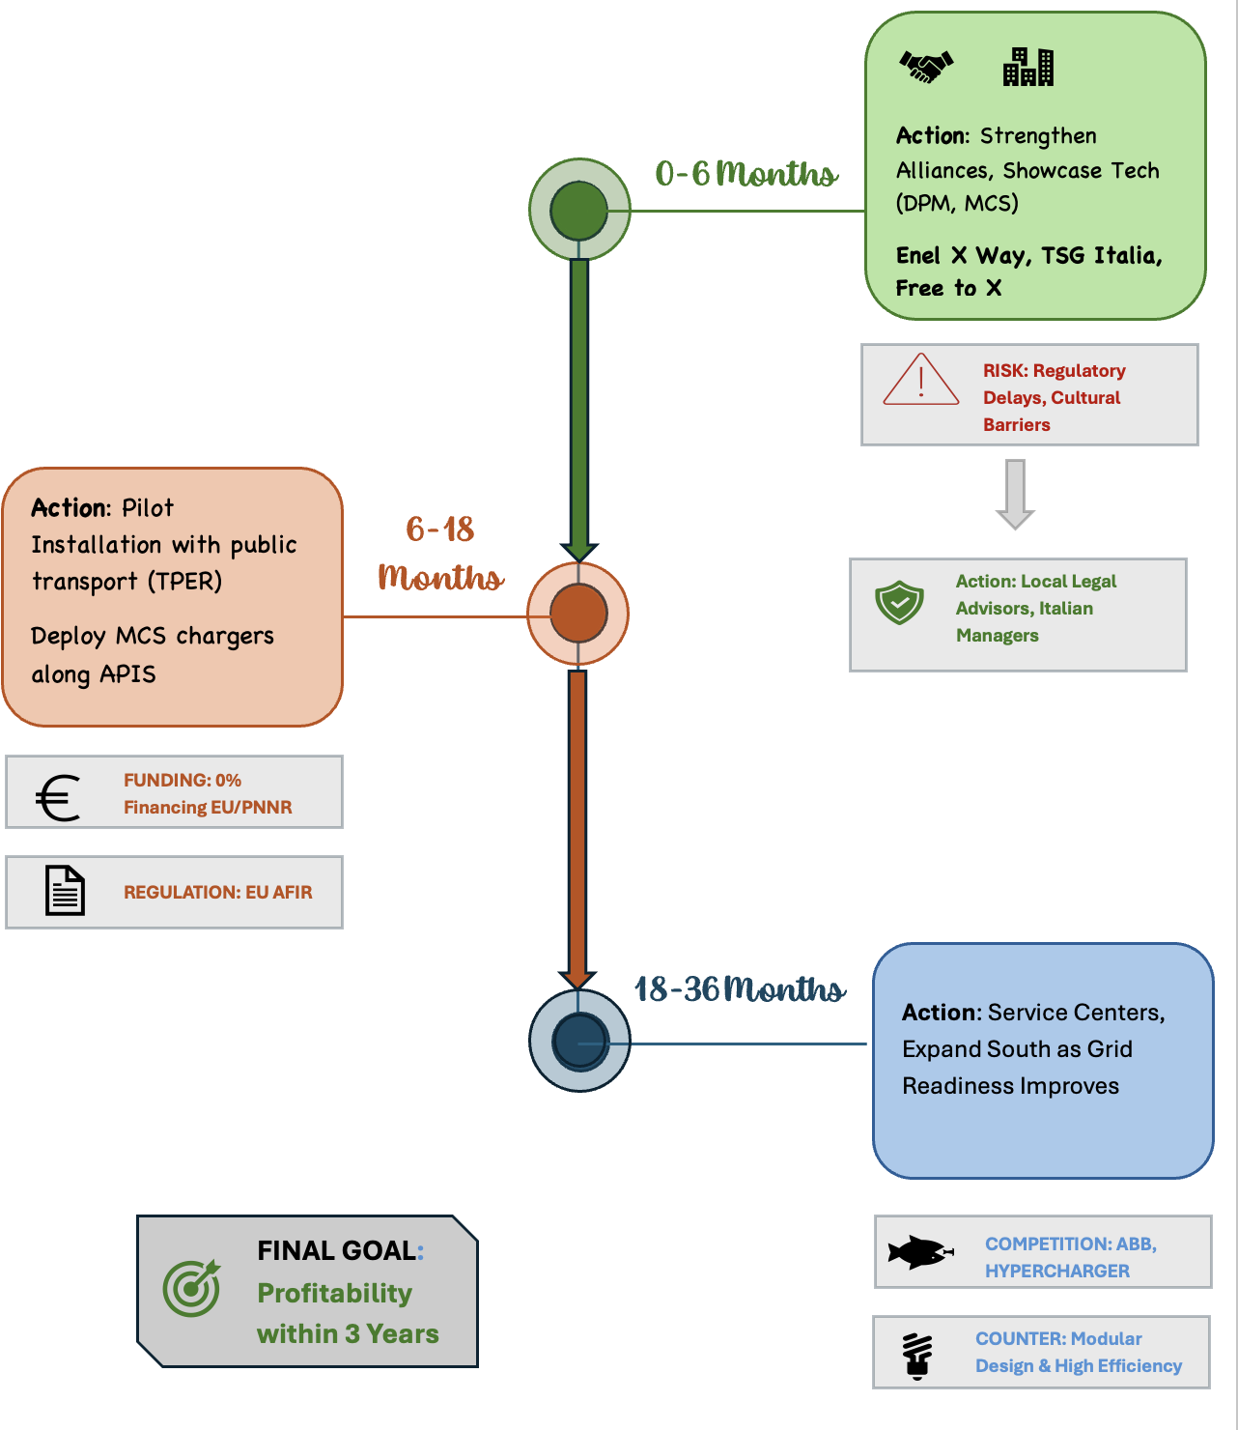

Conclusion
Italy presents a strategically aligned opportunity for Kempower’s European growth. The market’s expanding EV adoption, government incentives, and EU decarbonisation targets complement Kempower’s DPM and MCS technologies. While challenges exist, they can be mitigated through local partnerships and phased investment. Focusing first on the Northern regions of Italy will garner credibility and scalability before a potential nationwide rollout. Successful execution would improve Kempower’s competitive position and diversify revenue streams.

Bibliography
- Abu Eideh, O. (2021) ‘Colonnine di ricarica: circa 250 giorni lavorativi per agganciarle alla rete elettrica’, La Stampa, 6 August. Available at: https://www.lastampa.it/motori/attualita/2021/08/06/news/colonnine-di-ricarica-circa-250-giorni-lavorativi-per-agganciarle-alla-rete-elettrica- (Accessed: 30 October 2025).

- Aguilar, C. (2024) ‘Tesla Changes Sales Strategy With Captive Leasing and 0% Financing Instead of Price Cuts’, Autoevolution, 17 April. Available at: https://www.autoevolution.com/news/tesla-changes-sales-strategy-with-captive-leasing-and-0-financing-instead-of-price-cuts-232530.html (Accessed: 1 November 2025).

- Alpitronic. (n.d.) [Hypercharger]. Available at: https://www.alpitronic.it/en/hypercharger/ (Accessed: 20 October 2025).

- Alternative Fuels Observatory EC Europa. (2025, 19 August) Alternative Fuels General Information. Available at: https://alternative-fuels-observatory.ec.europa.eu/general-information/news/italys-eu600-million-ev-incentive-push-can-it-revive-new-car-market (Accessed: 19 October 2025).

- Alvarez, S. (2024) ‘Italy exploring partnership with Tesla, Chinese carmakers to bolster domestic auto industry: report’, Teslarati, 28 February. Available at: https://www.teslarati.com/italy-explores-partnership-tesla-domestic-auto-report/ (Accessed: 1 November 2025).

- Anariev Consulting (2025) Analysis of Italy’s EV Charging Infrastructure Landscape. Available at: https://www.anariev.com/analysis-of-italy-ev-charging-infrastructure-landscape/ (Accessed: 2 November 2025).

- Armellini, A. (2025) ‘Italy’s grid operator Terna to invest 23 billion euros over 10 years’, Reuters, 14 March. Available at: https://www.reuters.com/business/energy/italys-terna-invest-23-billion-euros-network-over-10-years-2025-03-14/ (Accessed: 30 October 2025).

- Autovista24 (2025a) ‘Can long-awaited BEV incentives jump-start Italy’s stagnant new-car market?’, 11 September. Available at: https://autovista24.autovistagroup.com/news/can-long-awaited-bev-incentives-jump-start-italys-stagnant-new-car-market/ (Accessed: 30 October 2025).

- Autovista24 (2025b) ‘Italy’s EV jeopardy continues as registrations stabilise in October’, 10 November. Available at: https://autovista24.autovistagroup.com/news/italys-ev-jeopardy-continues-as-registrations-stabilise-in-october/ (Accessed: 12 November 2025).

- Autovista Group News (2025, 7 October) Return to growth brings little respite for Italian new-car market. Available at: https://autovista24.autovistagroup.com/news/return-to-growth-brings-little-respite-for-italian-new-car-market/ (Accessed: 7 October 2025).

- Basma, H. and Schmidt, J. (2025) Charging needs for battery-electric trucks in Europe. [online] The International Council on Clean Transportation. Available at: https://theicct.org/publication/charging-needs-battery-electric-trucks-europe-oct25/ (Accessed: 5 November 2025).

- Brambilla, G. (2025) ‘Colonnine auto elettriche: flop bandi PNRR’, Open, 19 January. Available at: https://www.open.online/2025/01/19/colonnine-auto-elettriche-flop-bandi (Accessed: 2 November 2025).

- CMS (2023) CMS Infrastructure Index: Partnerships, Policies and Geopolitics. [online] Available at: https://giia.net/sites/default/files/2023-11/CMS%202023%20Infrastructure%20Index%20Report.pdf (Accessed: 29 October 2025).

- Cicero Shades of Green (2022) Kempower Corporation Shades of Green assessment. Europe: CICERO Company Assessment of Kempower. (Accessed: 20 October 2025).

- Comune di Reggio Emilia (2021) ‘Manifestazione di interesse per l’installazione di colonnine di ricarica per veicoli elettrici su area pubblica da assegnarsi in concessione’. Available at: https://www.comune.reggioemilia.it/amministrazione/documenti-e-dati/avvisi-e-bandi/altri-bandi/manifestazione-di-interesse-per-linstallazione-di-colonnine-di-ricarica-per-veicoli-elettrici-a-reggio-emilia (Accessed: 2 November 2025).

- Confcommercio (2025) ‘Bonus colonnine auto elettriche, gli incentivi per il 2025’. Available at: https://www.confcommercio.it/-/colonnine-ricarica-elettrica (Accessed: 2 November 2025).

- Economy Insights (2025) The supply chain behind the plug: Who builds the world’s EV chargers? Available at: https://www.economyinsights.com/p/the-supply-chain-behind-the-plug (Accessed: 12 November 2025)

- Electrive Infrastructure (n.d.) Kempower announces change in management. Available at: https://www.electrive.com/2025/05/06/kempower-announces-change-in-management/ (Accessed: 2 November 2025).

- Ellis, O. (2025) Is EV battery swap technology available in 2025? Available at: https://electriccarchargersuk.co.uk/blogs/is-ev-battery-swap-technology-available-in-2025/ (Accessed: 12 November 2025).

- European Alternative Fuels Observatory (2025a) ‘Italy launches Price Observatory for EV charging’, 29 January. Available at: https://alternative-fuels-observatory.ec.europa.eu/general-information/news/italy-launches-price-observatory-for-ev-charging (Accessed: 3 November 2025).

- European Alternative Fuels Observatory (2025b) ‘Italy’s €600 Million EV Incentive Push: Can It Revive the New Car Market?’, 19 August. Available at: https://alternative-fuels-observatory.ec.europa.eu/general-information/news/italys-eu600-million-ev-incentive-push-can-it-revive-new-car-market (Accessed: 30 October 2025).

- European Climate, Infrastructure and Environment Executive Agency (2024) ‘CEF Transport: Alternative Fuels Infrastructure Facility (AFIF) – Call for proposals’, 29 February. Available at: https://cinea.ec.europa.eu/funding-opportunities/calls-proposals/cef-transport-alternative-fuels-infrastructure-facility-afif-call-proposal_en (Accessed: 2 November 2025).

- European Commission (2023) Regulation (EU) 2023/1804 of the European Parliament and of the Council on the deployment of alternative fuels infrastructure (AFIR), 13 September. Available at: https://eur-lex.europa.eu/eli/reg/2023/1804 (Accessed: 2 November 2025).

- European Commission (2024) Italy’s recovery and resilience plan. Available at: https://commission.europa.eu/business-economy-euro/economic-recovery/recovery-and-resilience-facility/country-pages/italys-recovery-and-resilience-plan_en (Accessed: 29 October 2025).

- European Commission (2025, 1 October) Advancing high-performance charging for heavy-duty transport. Available at: https://alternative-fuels-observatory.ec.europa.eu/general-information/news/advancing-high-performance-charging-heavy-duty-transport (Accessed: 15 October 2025).

- EV Charging Business Guides (n.d.) Best EV charger manufacturers in Italy. Available at: https://electrly.com/ev-charging-business/best-ev-charger-manufacturers-in-italy (Accessed: 15 October 2025).

- Financial Times (2025) ‘FT1000: Europe’s Fastest-Growing Companies 2025 ranking’. Available at: https://www.ft.com/content/cb3e317e-e3cc-4e4a-a506-b755b2f94bb1 (Accessed: 29 October 2025).

- FIMER (n.d.) Products and services – our solutions. Available at: https://www.fimer.com/products-and-services/our-solutions (Accessed: 2 November 2025).

- Finders Seekers Blog (n.d.) Building a winning tech team: Insights from Pete Nieminen, CIO of Kempower. Available at: https://www.findersseekers.io/blog/building-a-winning-tech-team-insights-from-pete-nieminen-cio-of-kempower (Accessed: 2 November 2025).

- Gigieffe (n.d.) Products. Available at: https://www.gigieffe.com/en/#products (Accessed: 20 October 2025).

- Investors Kempower (n.d.-a) Governance. Available at: https://investors.kempower.com/governance/ (Accessed: 20 October 2025).

- Investors Kempower Governance (n.d.-b) Governance. Available at: https://investors.kempower.com/governance/ (Accessed: 22 October 2025).

- Italian Ministry of Enterprises and Made in Italy (2018) ‘“Industria 4.0” — Italy’s National Plan for Industry’. Available at: https://www.mimit.gov.it/images/stories/documenti/INDUSTRIA-40-NATIONAL%20PLAN_EN-def.pdf (Accessed: 29 October 2025).

- Kempower (2021, 18 November) Kempower News: Epiroc – global supplier. Available at: https://kempower.com/news/epiroc-kempower-global-supplier/ (Accessed: 25 October 2025).

- Kempower (2022a, 19 May) Kempower News: Autopromotec Bologna, Italy. Available at: https://kempower.com/news/autopromotec-bologna-italy/ (Accessed: 19 May 2022).

- Kempower (2022b) ‘Kempower delivers EV fast-charging systems to Power Dot in Portugal, Spain & France’. Available at: https://kempower.com/news/power-dot-portugal-spain-france-kempower/ (Accessed: 29 October 2025).

- Kempower (2024a) Annual Report 2024. [pdf] Available at: https://investors.kempower.com/wp-content/uploads/sites/2/2025/04/kempower_annual_report_2024.pdf (Accessed: 27 October 2025).

- Kempower (2024b) How Kempower electrified one of Europe’s largest bus depots in Italy. Available at: https://kempower.com/stories/how-kempower-electrified-one-of-europes-largest-bus-depots-in-italy/ (Accessed: 12 November 2025).

- Kempower (2025a) About us. Available at: https://kempower.com/about-us/ (Accessed: 11 November 2025).

- Kempower (2025b) Kempower expands US footprint with new PowerUp sites across the Southeast. Available at: https://kempower.com/news/kempower-expands-us-footprint-with-new-powerup-sites-across-the-southeast/ (Accessed: 12 November 2025).

- Kempower (2025c) Insider information: Kempower announces a leadership change; Bhasker Kaushal to be the new CEO. Available at: https://investors.kempower.com/releases/insider-information-kempower-announces-a-leadership-change-bhasker-kaushal-to-be-the-new-ceo/ (Accessed: 12 November 2025).

- Kempower (2025d) Kempower – DC fast charging solutions. Available at: https://kempower.com/ (Accessed: 12 November 2025).

- Kempower (2025e) Kempower and TSG drive public transport operator SETA’s e-bus transition in Italy’s Emilia-Romagna region with the opening of two ultra-fast charging depots. Available at: https://kempower.com/news/kempower-tsg-setas-e-bus-transition/ (Accessed: 12 November 2025).

- Kempower (2025f) Kempower Corporation Interim Report, 1 January–30 September 2025: Strong Growth and Performance. Available at: https://investors.kempower.com/releases/kempower-corporation-interim-report-1-january-30-september-2025-strong-growth-and-performance/ (Accessed: 2 November 2025).

- Kempower (2025g) Kempower reaches 3,000 charging points milestone in Norway. Available at: https://kempower.com/news/norway-3000-charging-points/ (Accessed: 12 November 2025).

- Kempower (n.d.-a) ChargeEye – EV charging management software solution. Available at: https://kempower.com/solution/chargeye-ev-charging-management-software-solution/ (Accessed: 9 November 2025).

- Kempower (n.d.-b) Code of Conduct. (Accessed: 2 November 2025).

- Kempower About Us (n.d.) Our locations. Available at: https://kempower.com/our-locations/ (Accessed: 7 November 2025).

- Kempower - Investments (n.d.) Key figures. Available at: https://investors.kempower.com/investment/key-figures/ (Accessed: 15 October 2025).

- Kempower Investment (n.d.) Growth strategy and sustainability. Available at: https://investors.kempower.com/investment/growth-strategy-and-sustainability/ (Accessed: 23 October 2025).

- Kempower Summer Trainee Program (2023, 14 December) Summer trainee program. Available at: https://kempower.com/summer-trainee-program/ (Accessed: 14 December 2023).

- Kempower, n.d.-a The benefits of dynamic charging of electric vehicles. [blog] Available at: https://kempower.com/the-benefits-of-dynamic-charging-of-electric-vehicles/ (Accessed: 30 October 2025).

- Kempower, n.d.-b Dynamic power management. [glossary] Available at: https://kempower.com/glossary/dynamic-power-management/ (Accessed: 29 October 2025).

- Kempower, n.d.-c ChargEye for CPOs and retail solution. [product page] Available at: https://kempower.com/solution/chargeye-for-cpos-and-retail/ (Accessed: 4 November 2025).

- Kempower, n.d.-d Kempower Megawatt Charging System. [product page] Available at: https://kempower.com/solution/megawatt-charging-system/ (Accessed: 1 November 2025).

- Kempower, n.d.-e Heavy Electric Traffic Ecosystem (HETE) Program boosted by €10 million. [news release] Available at: https://kempower.com/news/heavy-electric-traffic-ecosystem-program-boosted-by-10-million-euros/ (Accessed: 22 October 2025).

- Kempower Oyj (2024a) AFIR – Glossary. Available at: https://kempower.com/glossary/afir/ (Accessed: 2 November 2025).

- Kempower Oyj (2024b) Annual Report 2024. 2 April 2025. Available at: https://investors.kempower.com/wp-content/uploads/sites/2/2025/04/kempower_annual_report_2024.pdf (Accessed: 25 October 2025).

- Kempower Oyj (2025) KEMPOWR.HE stock quote – Yahoo Finance. Available at: https://finance.yahoo.com/quote/KEMPOWR.HE/ (Accessed: 12 November 2025).

- Kempower Oyj (2021) Annual Report 2021. 18 March 2022. Available at: https://investors.kempower.com/reports-materials/ (Accessed: 25 October 2025).

- Kempower Oyj (2022) Annual Report 2022. Available at: https://investors.kempower.com/investment/key-figures/ (Accessed: 25 October 2025).

- Kempower Oyj (2023) Annual Report 2023. 6 March 2024. Available at: https://investors.kempower.com/wp-content/uploads/sites/2/2024/03/kempower_annual_report_2023_final.pdf (Accessed: 25 October 2025).

- Kemptron (n.d.) Homepage. Available at: https://www.kemptron.com (Accessed: 8 November 2025).

- Köster, J., Himmelseher, S. and Funk, L. (2024) ‘Electric vehicle charging: new EU regulatory requirements’, Freshfields Sustainability, 7 October. Available at: https://sustainability.freshfields.com/post/102jkt3/electric-vehicle-charging-new-eu-regulatory-requirements (Accessed: 2 November 2025).

- Lardizabal, E. (2025) ‘Italy redefines its power grid: Terna implements microzones amid virtual saturation of 350 GW in renewable requests’, Strategic Energy Europe, 30 June. Available at: https://strategicenergy.eu/italy (Accessed: 30 October 2025).

- Lukuaika (2025, 12 August) Duunitori – Kempower careers. Available at: https://duunitori.fi/tyoelama/kempower-careers (Accessed: 12 August 2025).

- Magic, P. (2025) ‘Italy’s EV charging landscape in 2025: challenges and opportunities’, Zoniq, 26 February. Available at: https://www.zoniq.io/post/italy-ev-charging-landscape-in-2025-challenges-and-opportunities (Accessed: 2 November 2025).

- Market Observatory for Energy (2024) Quarterly report on European electricity markets – Q4 2023. Directorate-General for Energy, European Commission. Available at: https://static.smartgridsinfo.es/media/2024/06/New-Quarterly-Report-on-European-Electricity-markets-Q4-2023.pdf (Accessed: 30 October 2025).

- Mobilize & Autostrade per l’Italia (2025) Mobilize and Autostrade per l’Italia complete their strategic alliance to power sustainable mobility in Italy, 13 May. Available at: https://live.euronext.com/en/products/equities/company-news/2025-05-13-mobilize-and-autostrade-litalia-complete-their-strategic (Accessed: 2 November 2025).

- Mobility Portal (2025) ‘“Abuse of dominant position”: Italy fines Enel X €2 million’, 22 August. Available at: https://mobilityportal.eu/italy-fines-enel-x-2-million/ (Accessed: 3 November 2025).

- Morzenti, N. and Ruccione, F. (2024) EV Charging Index: Expert insight from Italy. Munich: Roland Berger. Available at: https://www.rolandberger.com/en/Insights/Publications/EV-Charging-Index-Expert-insight-from-Italy-2024.html (Accessed: 2 November 2025).

- Murray, A. (2025) ‘Norway on track to be first to go all-electric’, BBC News, 13 January. Available at: https://www.bbc.com/news/articles/cg52543v6rmo (Accessed: 12 November 2025).

- Posti (2025, 2 May) Latest news and articles. Available at: https://www.posti.fi/en/20240503-kempower-and-posti-to-begin-wide-cooperation (Accessed: 2 May 2025).

- PR Newswire (2025) Siemens, i-charging, ABB E-mobility, and Kempower take top spots in ABI Research’s commercial EV charging solution vendor competitive ranking, 15 July. Available at: https://www.prnewswire.com/news-releases/siemens-i-charging-abb-e-mobility-and-kempower-take-top-spots-in-abi-researchs-commercial-ev-charging-solution-vendor-competitive-ranking-302499111.html (Accessed: 10 November 2025).

- Savonen, P. (n.d.) Kempower recognized with excellent performance in ISO certifications for quality, environmental impact, safety of operations and information security. Available at: https://investors.kempower.com/releases/kempower-recognized-with-excellent-performance-in-iso-certifications-for-quality-environmental-impact-safety-of-operations-and-information-security/ (Accessed: 20 October 2025).

- SCAME (n.d.-a) Dynamic power management. Available at: https://www.scame.com/web/scame-uk/dynamic-power-management (Accessed: 20 October 2025).

- SCAME (n.d.-b) Home. Available at: https://www.scame.com/web/scame-uk/home (Accessed: 20 October 2025).

- Shijiazhuang Maxwell Technology Co., Ltd. (2025) Italy’s charging posts are booming. Available at: https://www.maxwellpower.cn/newsinfo/7389466.html (Accessed: 2 November 2025).

- Sipinen, J. (n.d.) Kempower. Available at: https://cloud2.net/references/kempower (Accessed: 9 November 2025).

- Squintani, L. (2019, 16 December) E-mobility: EIB to support Be Charge for charging network expansion in Italy. Available at: https://www.eib.org/en/press/all/2019-363-e-mobility-eib-to-support-be-charge-for-charging-network-expansion-in-italy (Accessed: 16 December 2019).

- Ursino, G. (2025) ‘Why are there no globally relevant Italian companies? The systemic approach to solving small business issues and irrelevance’, 24 February. Available at: https://giuseppeursino.it/en/italian-companies-bureaucracy-solution/ (Accessed: 29 October 2025).

- Virgillito, M. E., Cresti, L. and Sbardella, A. (2025) The automotive industry and the transition to electric mobility in Italy. ECCO Climate, April. Available at: https://eccoclimate.org/wp-content/uploads/2025/04/Study-The-Automotive-Industry-and-the-Transition-to-Electric-Mobility-in-Italy.pdf (Accessed: 30 October 2025).

- VT Markets (2025) ‘Business confidence in Italy rose from 87.3 to 88.3, reflecting improved economic sentiment’. Available at: https://www.vtmarkets.com/live-updates/business-confidence-in-italy-rose-from-87-3-to-88-3-reflecting-improved-economicsentiment (Accessed: 29 October 2025).

- Volkswagen Group (2022) Volkswagen and Enel X Way launch Ewiva to build Italy’s largest high-power charging network. Available at: https://www.volkswagen-group.com/en/press-releases/volkswagen-and-enel-x-way-launch-ewiva-to-build-italys-largest-high-power-charging-network-17210 (Accessed: 12 November 2025).

- Vuola, A. (2025, 28 August) Measuring true reliability in EV charging. Kempower Content Hub. Available at: https://kempower.com/measuring-true-reliability-in-ev-charging/ (Accessed: 28 August 2025).

- Zhao, X. (2022) Preferences and investments in electric vehicle fast charging: A study of Tesla’s Supercharging Network. Johns Hopkins University. Available at: https://xinyu-zhao-econ.github.io/assets/pdf/JMP.pdf (Accessed: 5 November 2025).

